DIE - IN

#psychologists4blacklives
MONDAY, APRIL 4TH

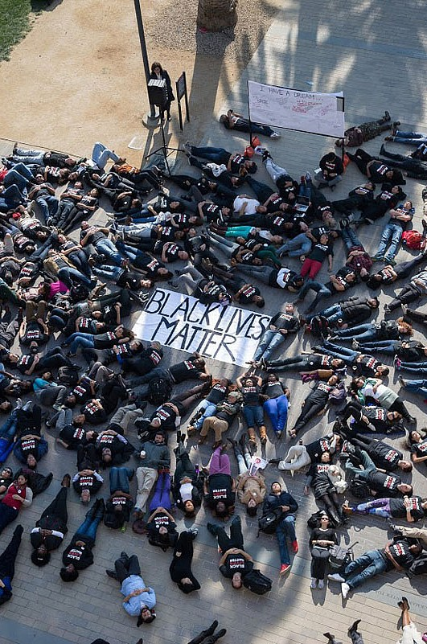
Citing a public mental health crisis resulting from excessive police violence against blacks and other minorities, and a lack of accountability on the part of political leaders, students will stage a die-in on Monday, April 4.

What: Students will stage a #psychologists4blacklives/
#BlackLivesMatter “Die-in”. The die-in will last 16 minutes – one minute for each bullet shot into Laquan McDonald.

When: Monday, April 4 at 5:00pm CST

Who: Graduate students in psychology, mental health professionals, faculty, staff, and anyone else who is interested in social justice.

Where:

Why: As mental health care professionals – counselors, psychologists, and others – the racism and poverty that our clients face are public health problems that have been neglected. We will not stand for the senseless killing of 17-year-old Laquan McDonald, for the excessive police violence in America equates to a public health crisis. Young African American males are 5 times more likely to be shot by

FOR MORE INFORMATION CONTACT:

a police officer than whites. Poor communities of color are far
more likely to be policed with excessive force and subjected to illegal searches. The killing of Laquan McDonald is a symptom of the long standing neglect and chronic high mortality from all causes in our country's neglected neighborhoods. We want to raise awareness of the mental health crisis and hold public officials responsible for ensuring that their agents “protect and serve” rather than attack and oppress.

